Name: MD FERDOUS SARKAR

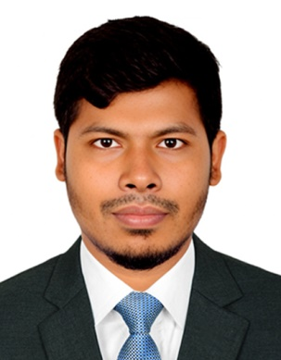

Father’s name: MD SORAF UDDIN

Mother’s Name: MST FIROZA BEGUM

Date of Birth: 02/06/1994

Course: Diploma in Agriculture (2020)

Address: BONOGRAM, Word no -03, LALMONIRHAT, KULAGHAT-5502, LALMONIRHAT

Name: MD SABU MIAH

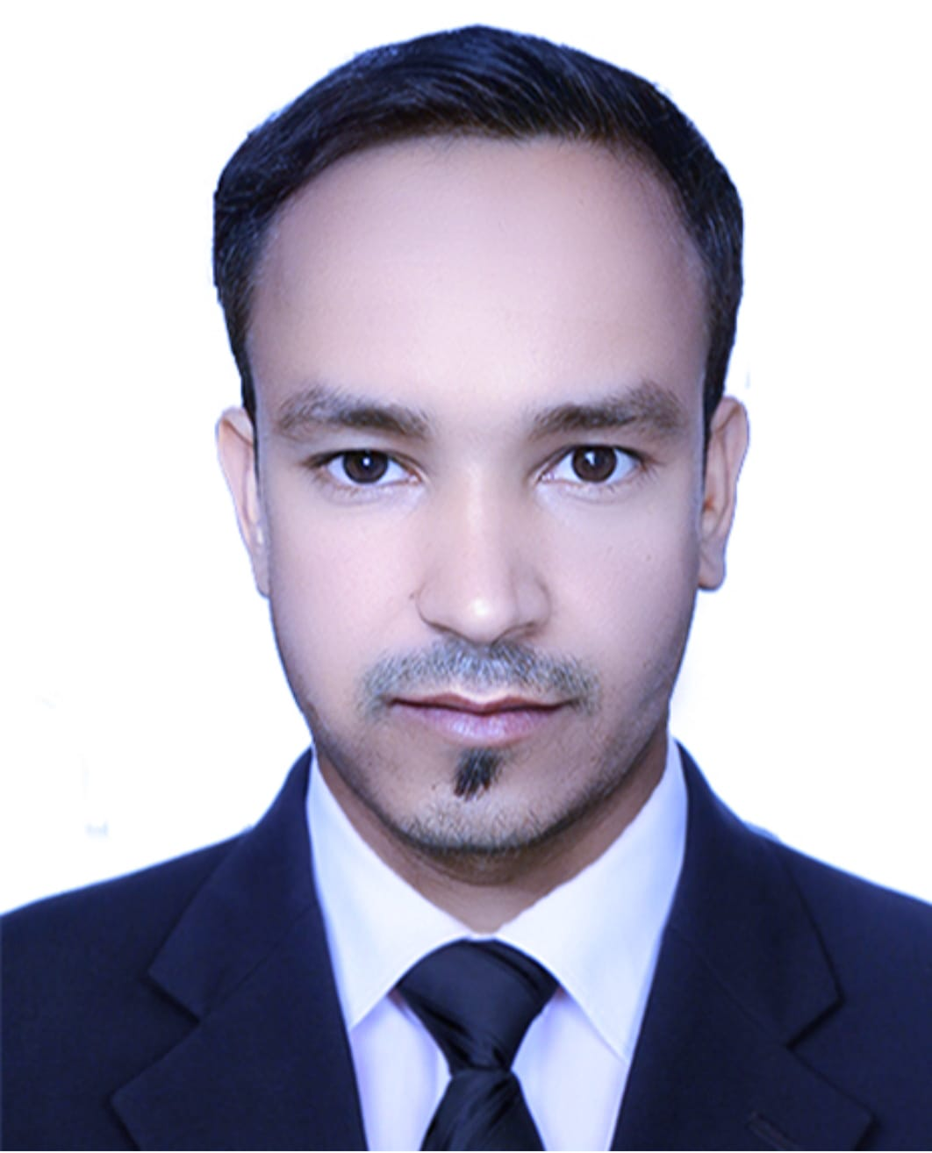

Father’s name: ANWAR MIAH

Mother’s Name: SAYRUN BEGUM

Date of Birth: 10-07-1991

Course: Diploma in Agriculture (2021)

Address: GOBINDOPUR, WARD NO 07, RAJNAGAR, MUKAMBAZAR-3120, MOULVIBAZAR